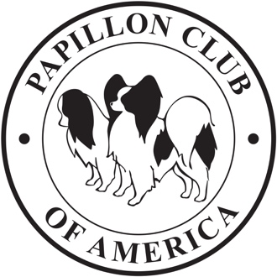

The Papillon Club of America, Inc.’s
2024 National Specialty
Auction & Raffle Donations
(updated as of 2024MAR08)

It’s that time once again to search around for anything you may have that you feel will be well received as a silent auction or raffle item, and of course donated gift baskets are always welcome. Additionally, PCA is also asking regional member clubs if they would be so kind as to make a monetary donation or donate a gift basket for raffle or auction. All donations received will be used to help defray the costs of holding our National.

Donations may either be brought to the National and given to the Chair listed below or sent by the date of show entries closing so that they can be received and prepared in time for the National.
For additional information please feel free to contact:

Kathy Patterson
352 Hampton Street
Elloree, South Carolina 29047
Ph: +1 (843) 224-8533
E-mail: pattersk1@yahoo.com

