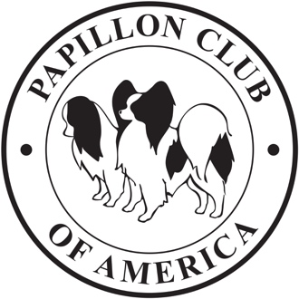

The Papillon Club of America, Inc.’s
2023 National Specialty
Catalog Ads
(updated as of 2023MAR28)

For Catalog Advertising please contact:

Janis McLaren, Catalog Ad Chair
24705 NE 14th St, Camas, WA 98607
Ph: +1 (360) 834-5485 or E-mail: larenpap@comcast.net

ADVERTISING DEADLINE: April 26, 2023

Placement: |  | Black & White |  | Color
 | Outside Back Cover – Call Janis for availability……………………..…… |  | $175.00 | $215.00
 | Inside Front Cover – Call Janis for availability……………………………. |  | $175.00 | $215.00
 | Inside Front Cover – Call Janis for availability……………………………. |  | $150.00 | $190.00
 | Inside Back Cover – Call Janis for availability……………………………. |  | $150.00 | $190.00
 | Two Page Spread…………………………………………………………….. |  | $100.00 | $140.00
 | Full Single Page………………………………………………………………. |  | $55.00 | $95.00
 | Half Page (Black and White Only)………………………………………….. |  | $30.00 | N/A
 | Quarter Page (Black and White Only)……………………………………… |  | $15.00 | N/A

CATALOG AD REQUIREMENTS GENERAL INFORMATION
IMAGE AREA:
- Catalogs pages are 5-1/2” x 8-1/2.” We do not accept ads that bleed outside the image areas listed below.
- FULL PG. .. 4-1/2” x 7-1/2” (27 picas x 45 picas)
- HALF PG. . 4-1/2” x 3-5/8” (27 picas x 22 picas) – no vertical half-page ads
- QUARTER PG. . 4-1/2”x 1-3/4” (27 picas x 11 picas) – no vertical quarter-page ads
Above image areas must include the border (if applicable).
- Acceptable formats for electronically submitted ads: High Resolution, “Press Quality” PDF file • “tiff” or “JPG” file 300 DPI resolution • Microsoft Word file (With Word files, we may not be able to reproduce exact fonts unless fonts are included separately with your submission).
- The following formats will NOT be accepted: Microsoft Works, Publisher, PowerPoint, or Excel. These formats must be converted to PDF or JPG before submission.
- If you have any questions, please contact larenpap@comcast.net .

